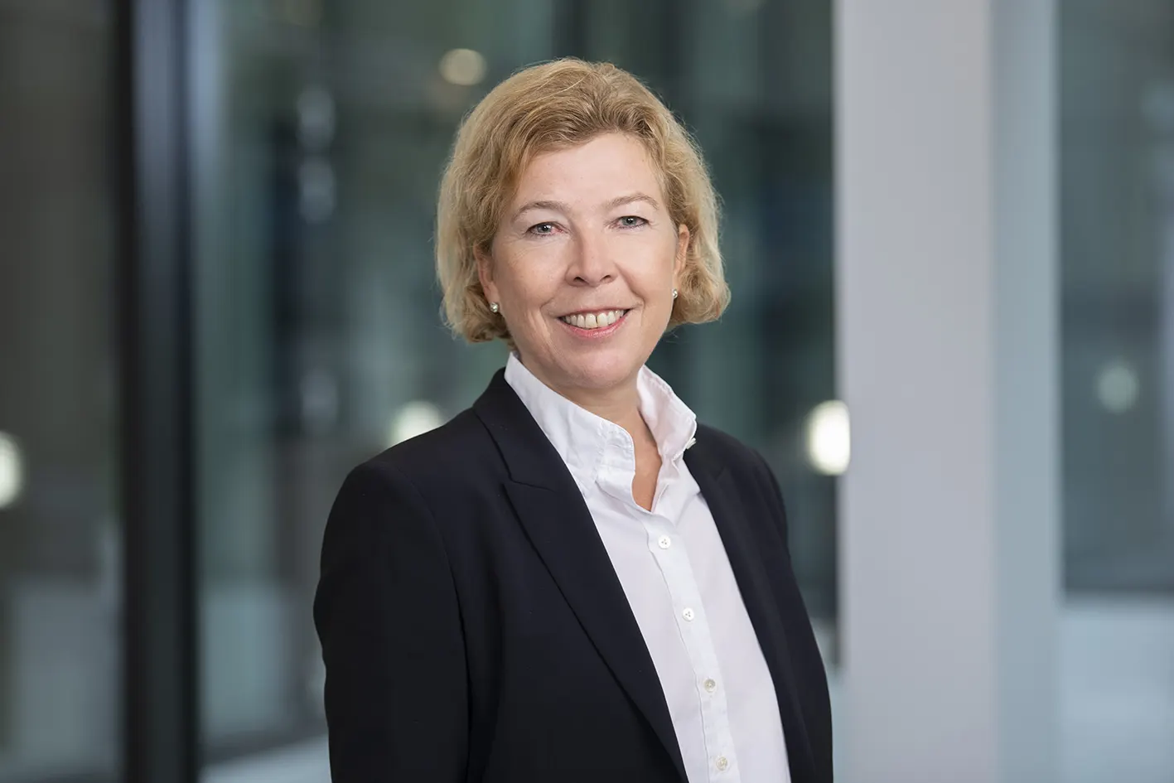
Steel Europe
03|01|2024

Dr. Heike-Denecke-Arnold – Chief Operating Officer (COO)

Dr. Heike Denecke-Arnold joined the Executive Board of thyssenkrupp Steel Europe AG on May 1, 2022, and is responsible for sales, sales steering, production planning and for production operations from upstream operations down to the finishing stages, as well as quality and logistics.

Dr. Heike Denecke-Arnold has held various positions at thyssenkrupp since 1999. Her areas of activity included blast furnace technology, marketing & sales service and a position as executive assistant. From 2006 to 2009, she was head of controlling in the Industry unit, and from 2010 to 2016 head of sales strategy and planning. In 2016, Dr. Denecke-Arnold took over as CEO and CTO of thyssenkrupp Hohenlimburg GmbH.

Dr. Heike Denecke-Arnold, born 1970, studied metallurgy and materials engineering at RWTH Aachen University before earning her PhD in metallurgy there in 1999.

