Press release

Realisation agreement for the connection of thyssenkrupp Steel to the future hydrogen network has been signed

- Nowega, OGE and Thyssengas are connecting thyssenkrupp Steel's steelworks in Duisburg to the planned German hydrogen network and the import route from the Netherlands.
- The infrastructure ties in with the GET H2 projects and is to become part of the core network for hydrogen.
- The pipelines are planned to be ready for operation by 2027 and the thyssenkrupp Steel connection by 2028.

March 21,2024. As early as 2028 the thyssenkrupp Steel plant in Duisburg is to be connected to the GET H2 network, which is to become part of the planned German hydrogen network. The transmission system operators Nowega, OGE and Thyssengas have now signed a realisation agreement with the steel manufacturer. thyssenkrupp plans to convert steel production in Duisburg to green hydrogen in the future and thus reduce CO2 emissions by up to 3.5 million tonnes per year with the construction of a first direct reduction plant with smelters. The pipelines link the Duisburg-Walsum site with the GET H2 network and the Dutch import routes via the border crossing point Vlieghuis.

The GET H2 pipeline coming from Lingen will be extended via a new 40-kilometre pipeline from Dorsten to Duisburg-Walsum, where it will connect to the steelworks. To open up the import route, existing pipelines between Vlieghuis in the Netherlands and Kalle (Grafschaft Bentheim, Lower Saxony) and onwards to Ochtrup will be converted to transport hydrogen and connected to the GET H2 pipeline system. All pipeline sections are scheduled to be operational in 2027, with thyssenkrupp Steel to be connected in 2028.

"With this contract, the hydrogen economy in North Rhine-Westphalia and Germany continues to take shape," the companies emphasise. "We are thus creating the opportunity to continue preparing the building blocks despite the fact that political decisions are still pending." The pipelines are to be part of the hydrogen core network, the financing of which is not expected to be officially decided until March in the amendment to the Energy Industry Act.

The contract that has now been signed regulates the conversion and construction of the hydrogen pipelines as well as the mutual rights and obligations of the contractual partners until the start of operations. In addition, the necessary starting points for cooperation between the project partners in the future market for non-discriminatory network access have been established.
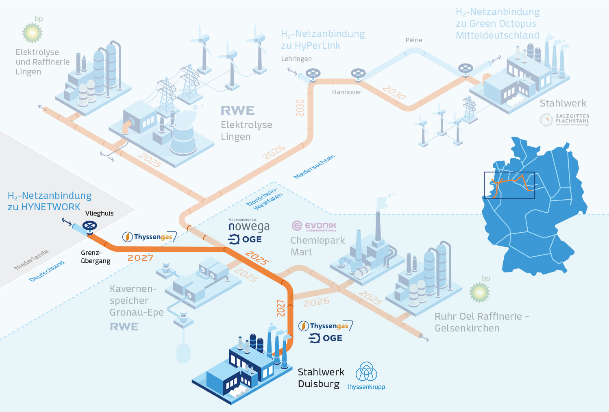

Caption: The connection of thyssenkrupp Steel to the GET H2 network and the import route via the Netherlands has now been concretised in a realisation agreement with Nowega, OGE and Thyssengas. The other parts of the GET H2 network include the connection of electrolysis plants and other users and networks in North Rhine-Westphalia and Lower Saxony.

Press contact:

Nowega OGE
Kai Tenzer Kristian Peters-Lach
presse@nowega.de Kristian.peters-lach@oge.net
+49 251 60998-345 +49 201 3642-1262

thyssenkrupp Steel Thyssengas
Roswitha Becker Peter Alexewicz
roswitha.becker@thyssenkrupp.com peter.alexewicz@thyssengas.com
+49 203 5244916 +49 231 91291-3189

The contract partners:

Nowega GmbH
Nowega GmbH is a transmission system operator based in Münster. The subsidiary of Erdgas Münster GmbH operates, maintains and markets around 1,500 kilometres of high-pressure gas pipelines. The pipeline network stretches from the Dutch border right across Lower Saxony and parts of North Rhine-Westphalia to Wendland and is part of the intra-European transport routes for natural gas.

Open Grid Europe GmbH
OGE is one of the leading transmission system operators in Europe. With our approximately 12,000 kilometres of pipeline network, we transport gas throughout Germany and, due to our geographical and, due to our geographical location, we are the connecting link for gas flows in the European internal market. Our 1,450 employees stand
for security of supply. We make our network available to all market participants
in a non-discriminatory, market-driven and transparent manner. We shape energy supply. Today and in the energy mix of the future.

thyssenkrupp Steel
thyssenkrupp Steel is one of the leading manufacturers of carbon steel flat products and stands for innovations in steel and high-quality products for the most modern and demanding applications - such as economical lightweight construction, high-quality surfaces and efficient steels for the energy and mobility transition. thyssenkrupp Steel employs around 26,000 people and, with an annual production volume of around 11 million tonnes of crude steel, is the largest flat steel manufacturer in Germany. As a pioneer in the climate transformation, thyssenkrupp Steel has set itself the goal of avoiding more than 30% of CO₂ emissions annually by 2030. By 2045 at the latest, steel production is to be completely climate-neutral.

Thyssengas GmbH
Thyssengas GmbH is a German transmission system operator. The company, which celebrated its 100th anniversary in 2021, is headquartered in Dortmund. Thyssengas operates a gas network around 4,400 kilometres long - mostly in North Rhine-Westphalia, but also with individual pipelines in Lower Saxony. It supplies downstream distribution network operators as well as industrial companies and power plants. Thyssengas is focussing on hydrogen as a gaseous energy source for a climate-neutral future. The Dortmund network operator is involved in numerous initiatives to this end. At the same time, it is making targeted investments in the conversion of its pipeline system to enable a rapid hydrogen ramp-up as part of the energy transition. The company currently employs around 450 people at seven locations in the grid area, and the number is growing.

